Visit to the Centre for Integration of refugees SOL

On Tuesday, September 6 2018 Andreja Pevec, school coordinator of the project MIERC, visited Centre for Integration of refugees SOL in Zagreb. This centre is organised by Jesuit Refugee Service (JRS), international catholic organisation with a mission to serve and advocate for the rights of refugees. Mission of the centre SOL is to empower refugees in their integration through learning Croatian, support in finding a job and encounter with local community. Togehter we are planning integration encounters of refugee children and our students.

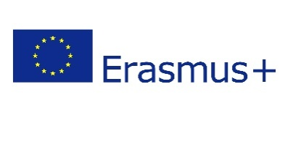
Projekt se provodi u sklopu programa Erasmus+ i sufinanciran je sredstvima Europske unije. Ovaj tekst odražava isključivo stajalište autora publikacije i Komisija se ne može smatrati odgovornom prilikom uporabe informacija koje se u njoj nalaze.

